BRAND STYLE GUIDE
Bhutan-Luxe

The Bhutan Few Will Ever See

CONFIDENTIAL
April 2026

Company overview
Bhutan Luxury Travel curates bespoke group journeys for high-net-worth individuals, primarily based in Texas. We deliver rare access to Bhutan with exceptional comfort, discretion, and white-glove execution.
Our focus: fewer guests, deeper experiences. We unlock remote regions, sometimes by helicopter when needed, providing seamless tours from start to finish. Our guests experience a Bhutan that few will ever see.

Target audience: High-net-worth individuals and their networks in Texas
Price range: $8,000 to $27,000+ per person
Differentiator: Access to places that few can experience
Partner model: Affiliate partner in Bhutan handles local arrangements

Color palette
Drawn from the Bhutan national flag and the country's natural landscape, refined for a luxury positioning. No gradients. Flat, solid colors only.

Primary colors
 | Bhutan Saffron | #FF8C00 | CTAs, accent elements, highlights. Signals warmth, spirituality, and tradition.
 | Bhutan Crimson | #C41E3A | Emphasis, hover states, tier badges. Conveys power and exclusivity.

Secondary colors
 | Forest Green | #2D5016 | Secondary text, section backgrounds, trust elements.
 | Cloud White | #F7F5F0 | Primary background. Warm off-white, like handmade paper.
 | Monastery Stone | #3B3A36 | Body text. Warm near-black, softer than pure black.

Accent
 | Himalayan Gold | #D4A843 | Borders, dividers, subtle luxury cues. Aged gold, not flashy.

Typography

Headlines
Use a refined serif typeface: Playfair Display or Cormorant Garamond. Normal weight with generous letter-spacing. These fonts carry weight and tradition without feeling stuffy.

Body text
Clean sans-serif: Inter. Readable, modern, and does not compete with imagery. Standard weight, natural tracking.

Labels and navigation
Uppercase Inter with wide tracking. Small, confident, quiet. Use for tier names, form labels, section navigation, and CTAs.

Element | Font | Weight | Size
Headline | Playfair Display | Regular (400) | 32-48px
Subheadline | Inter | Medium (500) | 20-24px
Body | Inter | Regular (400) | 15-16px
Label / CTA | Inter (uppercase) | Medium (500) | 11-12px
Caption | Inter | Regular (400) | 12-13px

Photography direction
This is where the brand lives or dies. Every image should feel like it was taken by someone who was invited, not someone who bought a ticket.

Do use
- Mist over valleys at dawn, not sunny postcards
- Monks in motion, not posed portraits
- Empty trails, not group shots
- Helicopter shadows over untouched snow, not the helicopter itself
- Natural light only. No flash, no HDR, no oversaturation

Visual tone
Reverent. Unhurried. Intimate. Every photo should make the viewer feel like they are seeing something they were not supposed to see.

Layout principles
Full-bleed imagery: Let the landscape do the work. Text overlays on hero images, not beside them.
Generous whitespace: This audience equates space with luxury. Cramped layouts signal budget travel.
Single-column flow: No sidebars, no grid clutter. One narrative, one scroll.
Max content width: 960px, centered. Let the edges breathe.
No gradients: Flat, solid colors only. Gradients cheapen the feel.
Minimal UI: No carousels, no pop-ups, no chatbots. One page, one scroll, one form.

Voice and tone
Write like a private concierge, not a travel agency.

Rules
- Short sentences. No exclamation marks. No "amazing" or "breathtaking."
- State facts that imply exclusivity. "Limited to eight guests per departure" beats "An exclusive experience!"
- Use restraint. If the copy feels like it is selling, cut it in half.
- First person plural sparingly: "We arrange" not "We are thrilled to offer."
- Describe less, suggest more. Let the reader's imagination do the work.

Example (good)
Three valleys in eastern Bhutan have no roads, no lodges, no cell signal. We access them by helicopter. You can be among the first outsiders to set foot there.

Example (avoid)
Experience the amazing, breathtaking beauty of Bhutan's untouched eastern valleys on our exclusive helicopter tour!

Experience tiers
Three tiers, each progressively more exclusive. Present as cards on the website, each with a single hero image and a "Request Details" CTA.

Tier | Price | Duration | Description
Luxe | $8-12K | 7 days | Cultural immersion, monastery visits, luxury lodge stays. Accessible entry point.
Boutique-Luxe | $12-25K | 10 days | Gateway access to remote valleys, private ceremonies, wild glamping.
Ultra-Luxe | $25-35K | 10 days | Fully customized. Chopper to trailless regions. Private audiences

We are can also collaborate with you and our affiliate Bhutan partner on the ground there to create your own itinerary based on your interests (spiritual, outdoor, etc.), number of days and estimated price.

Website structure
Single-page scroll. Six sections. The site's job: create desire, present tiers, capture qualified leads. Everything after that is human-to-human.

1. Hero / Hook
Full-bleed landscape image. Single powerful headline. One CTA: "Enchanted Bhutan." No navigation clutter.

2. The Desire
Speak to the HNWI mindset: "You have been everywhere. Bhutan is the exception." Short copy, cinematic imagery. Frame exclusivity and scarcity.

3. Experience Tiers
Three cards (Luxe, Boutique-Luxe, Ultra-luxe). Each with hero image, brief description, and "Request Details" button scrolling to form.

4. Trust and Credibility
Partnership credentials. Brief bios. Quotes from past travelers when available. No long narratives. https://www.mybhutan.com/

5. Interest Form
Name, email, phone, tier selection, preferred travel window, group size, optional open text. This is a concierge inquiry, not a booking form.

6. Footer
Contact email. WhatsApp link. Privacy/discretion note. Minimal.

Rare.Bhutan@bhutan-luxe.com

Logo direction
A wordmark in the serif headline font paired with a minimal mountain silhouette. Use the saffron/crimson palette. Keep it simple and restrained.

Include: Mountain silhouette, saffron and crimson tones, serif wordmark
Avoid: Dragons (too literal), prayer flags (too tourist), complex illustrations, gradients

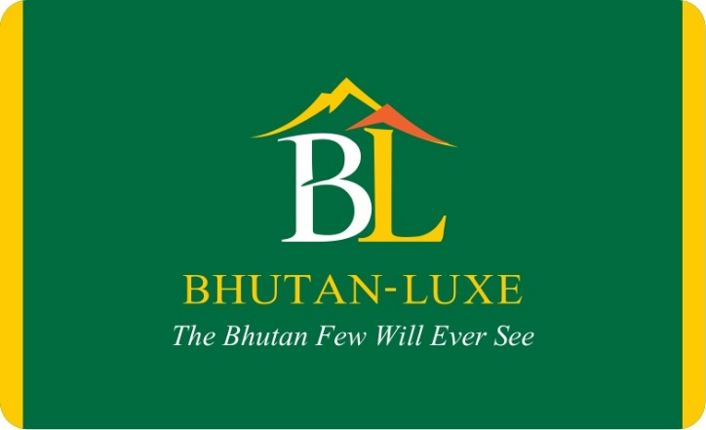

Technical notes
Stack: Next.js on Vercel. Static pages with a single form endpoint.
Form routing: Webhook to Lark, Airtable, or email via Resend/SendGrid.
No database needed: At this stage, the site captures leads only. Follow-up is by phone.
Performance: Optimize images aggressively. Full-bleed photos must load fast on mobile.
Mobile: Single-column layout works natively. Test tier cards for thumb-friendly tap targets.

